

From: Robert Lieb

To: Christoph Gorder

Charity Water

CC: Paul Severino, Craig Brekne

IPS

Date: Nov 28, 2018

Subject: Afridev2 Validation Testing Report

# Introduction

This document is a report of the Firmware Validation Testing performed on the Afridev2 Firmware. The scope of this test is the unit’s ability to send and receive messages over a 2G WAN connection to the Body Trace server, and the unit’s ability to measure water and process OTA commands received from the server.

There are no interactions with iot.charitywater.org, as the backend server (developed by Twisthink and Spindance) was not available at the time of testing.

## Equipment used during Test

|  |
| --- |
|  |

The following equipment/software is required for performing these actions per assembly station:

1. A laptop with 2 USB ports (running MS Windows 7, 8 or 10, 32 or 64bit
2. TI MSP-FET Flash Emulation Tool
3. TI MSP-FET432ADPTR
4. Micro USB cable
5. USB Serial Adapter Cable TTL-232R-3V3
6. Afridev2 Harness Cable (made by IPS)
7. Small storage container for holding water
8. Ajay Afridev Pump mounted to plywood over a container with several gallons of water

## Units under Test

The tests were run with the following:

* 10 boards that were manufactured by VIQUEST TECHNOLOGIES LTD received on Oct 21 2018
* 10 housings, screws, and metal brackets that were manufactured by VIQUEST TECHNOLOGIES LTD received on Nov 5 2018
* 1 board that was manufactured in the US by another vendor
* 1 housing that was manufactured by VIQUEST at an earlier date
* 11 Tadrian 3.6V Batteries

## Board Configurations

The boards were programmed using the Assembly procedure. This includes mounting the board in the housing and sealing the unit with the 5 inner screws. The 8 outer screws were only added on board 15 to be installed on the well. 6 of the boards were given brand new batteries, the rest were tested with used batteries.

|  |  |  |  |  |  |
| --- | --- | --- | --- | --- | --- |
| Board# | IMEI | Bat | FW  Ver | LED | On  Well |
| 3 | 861508039384946 | New | 8F | No | No |
| 8 | 861508039416912 | New | 8F | No | No |
| 9 | 861508039382056 | New | 8F | No | No |
| 11 | 861508039384169 | New | 8F | No | No |
| 12 | 861508039381983 | New | 8F | No | No |
| 14 | 861508039384136 | Old | 8F | No | No |
| 15 | 861508039416342 | Old | 0F | No | Yes |
| 16 | 861508039417977 | New | 8F | Yes | No |
| 17 | 861508039384144 | Old | 8F | No | No |
| 19 | 861508039416888 | Old | 8F | No | No |
| 20 | 861508039383583 | Old | 8F | No | No |

# Testing Performed

The 11 units under test were tested as they would be used in the field. The following state chart shows the major operating states of the Afridev2 unit. The testing’s goal is to exercise the units through all 5 of these states to be sure they are operating properly.

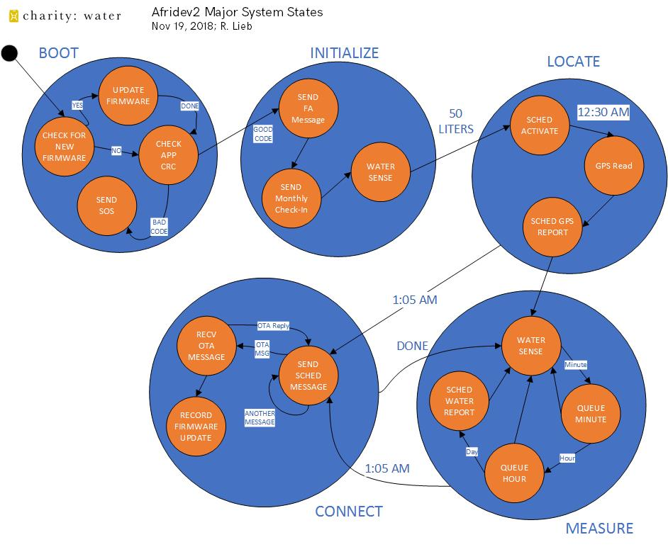

## Modem Verification

The units were looked up on the BodyTrace server to be sure that the FA and Monthly Check-In messages were received.

The data from the FA message was cut and pasted into the cwtest.exe utility to determine the Set Current GMT message and Update Transmission Rate messages to send to the unit. These are queued up to send to the Body Trace Server. This manual step was added because the Dispatch Monitor service on Charity Water’s backend server was stopped.

They are processed at the next 24 hour update time (which is not yet at 1:05 am GMT).

The times between sending the FA message and the Monthly Check-In varied from 1 minute to several minutes

## Unit Activation

Once the units were sealed up, they were repeatedly plunged over a tank of water (inverted upside down) so that all the pads were covered with water. This simulated the use with a well.

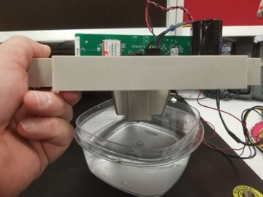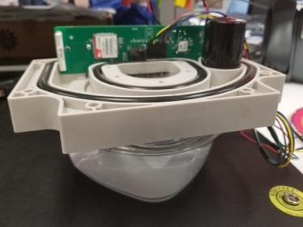

Each unit was dunked for 30 seconds at a time, repeated 3 or 4 times. This provides enough water measurements to exceed the 50 liter activation requirement.

## GPS Fixes

Overnight, the units are placed in a location where the GPS satellites are accessible.

The accuracy of the GPS Fixes measured during the test is shown in this diagram. The units (all but 15) were in the vicinity of the blue circle. The markers show the measured coordinates. The blue circle is the location of the devices inside my home, the red markers are the readings made by the Afridev2 device. Board 15 got was measured while in my car. It is possible boards 3 and 14 were in my car when they measured.

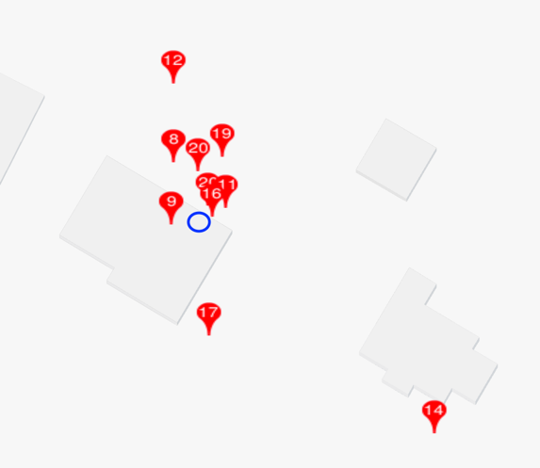

Here are the measurements. The firmware is looking for a GPS fix with at least 4 satellites, an HDOP value of 3.0 meters or less in no less than 60 seconds or more than 5 minutes.

| Board# | Latitude | Longitude | Sats | HDOP | Meas Time | Accuracy  (approx.) |
| --- | --- | --- | --- | --- | --- | --- |
| 3 | 40 47.xxxxN | 73 10.xxxxW | 6 | 1.5 m | 80 sec | 48.8 m |
| 8 | 40 47.xxxxN | 73 10.xxxxW | 6 | 1.6 m | 68 sec | 5.5 m |
| 9 | 40 47.xxxxN | 73 10.xxxxW | 5 | 2.1 m | 68 sec | 3.0 m |
| 11 | 40 47.xxxxN | 73 10.xxxxW | 6 | 1.3 m | 68 sec | 3.0 m |
| 12 | 40 47.xxxxN | 73 10.xxxxW | 6 | 1.4 m | 68 sec | 12.2 m |
| 14 | 40 47.xxxxN | 73 10.xxxxW | 7 | 1.3 m | 68 sec | 30.5 m |
| 15 | 40 49.xxxxN | 73 04.xxxxW | 8 | 1.0 m | 68 sec | unknown |
| 16 | 40 47.xxxxN | 73 10.xxxxW | 4 | 2.4 m | 116 sec | 0.9 m |
| 17 | 40 47.xxxxN | 73 10.xxxxW | 5 | 1.9 m | 68 sec | 12.2 m |
| 19 | 40 47.xxxxN | 73 10.xxxxW | 7 | 1.2 m | 68 sec | 6.1 m |
| 20 | 40 47.xxxxN  40 47.xxxxN | 73 10.xxxxW  73 10.xxxxW | 6  8 | 1.4 m  1.2 m | 68 sec  68 sec | 0.9 m  4.0 m |

## Water Sensing

All of the boards were delivered by VIQUEST in static dissipative bags with a desiccant bag inside to keep the board dry. In the production of boards, there is a variation in board thickness that can be expected. Thinner boards will yield lower capacitance measurements, as well as boards that have been exposed to moisture.

### Capacitance Measurements

All of the boards except two were sensing water at the expected accuracy rate. During the test, Board 12 was showing a malfunction where the water detection was “stuck” on. Board 16 showed an unexplained high activation water detect measurement.

Digging deeper into the failure, looking at the measured air capacitance values, the boards must have picked up moisture.

For measuring air, the boards should optimally measure greater than 0x9000 and less than 0xA300. The Board 12 and 16 values were suboptimal. For manufacturing screening, we are setting the lowest allowed value to 0x8000. Board 16 would have failed.

|  |  |  |  |  |  |  |
| --- | --- | --- | --- | --- | --- | --- |
|  | Pad 0 | Pad 1 | Pad 2 | Pad 3 | Pad 4 | Pad 5 |
| 12 | 0x8fd5 | 0x8243 | 0x8e7e | 0x84b2 | 0x9345 | 0x93d6 |
| 16 | 0x8e29 | 0x796f | 0x883f | 0x7f46 | 0x93dc | 0x92ff |

To dry the boards out, I put them in a 70C oven overnight and the values were better.

|  |  |  |  |  |  |  |
| --- | --- | --- | --- | --- | --- | --- |
|  | Pad 0 | Pad 1 | Pad 2 | Pad 3 | Pad 4 | Pad 5 |
| 12 | 0x9a05 | 0x821c | 0x91e3 | 0x8785 | 0x9c4f | 0x99db |
| 16 | 0x9a4b | 0x825e | 0x9232 | 0x87c7 | 0x9cab | 0x9a11 |

This board was setup for a follow-up test to be sure it does not report stuck measurements again.

### Unknowns

The Afridev2 water sensing algorithm independently detects the presence of water or air over each of the 6 pads. An “unknown” water state exists when a pad has water detected over one or more pads that has air detected. This water is ignored in water measurements.

The following data was seen in the week of testing. From the data reported, unknowns only occurred in hour slots where the units were dunked in water. There was no water reported because of unknowns.

|  |  |
| --- | --- |
| Board# | Unknowns |
| 3 | 0 |
| 8 | 64 |
| 9 | 39 |
| 11 | 1 |
| 12 | 2 |
| 15 | 5 |
| 17 | 41 |
| 19 | 2 |
| 20 | 0 |

There are several reasons why an unknown can happen:

#### Splashing/dripping

The most common cause of unknowns is dripping of water. When the water enters the pump chamber, it is possible for the initial splashes of water over the pads to hit the higher sensors before the lower ones.

#### Temperature Shifting

When the temperature of air or water gets warmer, the capacitance measurement goes lower. If the air temperature gets warm enough it could cause a false water report. The Afridev2 unit has a temperature sensor just below the pads (inside the unit) to track the lowering of capacitance values. To help prevent false water reports, the water sensing algorithms adjust its air and water targets every 20 seconds if the pad air temperature changes up or down “0.1C”. The temperature sensor can be lagged from the current temperature due to restricted air flow inside the unit, so temperature caused unknowns can still happen.

#### Moisture on the board

If the measurement pads get wet, it is possible for the capacitance measurements to go lower. The seals of the unit should prevent this from happening.

## OTA Messages

### Set Current GMT

The GMT was originally set by the Dispatch Monitor service on Charity Water’s backend server. This was disabled by Twisthink during their development efforts. I manually entered Set Current GMT commands and saw that the unit responded to them.

### GPS Request

I issued a few manual GPS Requests, and the system took the measurements and reported the data the next reporting period

### Update Transmission Rate

I updated the Transmission Rate to 1 day for every unit, just following the transmission of the FA and Monthly Check-In messages. The daily Water updates started a day after the Update Transmission Command was received.

## General Observations

### NULL Reports

The Body Trace server reported “Null” messages occasionally. They mostly occurred before or after GPS Reports. The UART on the Afridev2 board is shared between the Modem Module and the GPS module. It is believed that the Modem Module generates a null report when the UART is switched to and from the modem.

|  |  |
| --- | --- |
| Board# | Nulls |
| 3 | 1 |
| 8 | 2 |
| 9 | 1 |
| 11 | 1 |
| 12 | 1 |
| 14 | 1 |
| 15 | 2 |
| 17 | 1 |
| 19 | 2 |
| 20 | 4 |

### Red Flags

A few select units were setup to have the water history loaded in advance to be 240 liters a day. These units correctly reported the red flag in the Daily Water reports when the measured water volume was under the 25% target.

### Firmware Update

A complete firmware update was done on a single unit. The Body Trace server reported all sorts of “yellow” entries as the server does not know of the Firmware Update message. However, the update was programmed successfully.

### SOS Messages

No SOS messages occurred during this test. Several weeks ago there were a few occasions when the Boot Loader sent SOS messages when the main application’s checksum was not correct. The error reporting worked correctly and ended when a new program was loaded.